# Name: _____________________________________

# MineralS and THEIR Properties

If any of the following statements is a characteristic of a mineral, place a tick beside it. **If it is not, leave it blank**.

1. __________Made of one or more elements on the periodic table
2. __________Is formed by years of compression under the earth’s crust
3. __________Is formed by cooling after a volcanic eruption
4. __________Is a solid
5. __________Has a unique crystalline shape
6. __________Can be melted easily with a simple campfire
7. __________Has lustre, a hardness number and specific density
8. __________Is usually found on the coastal areas of the United States

We use different tests to identify a mineral. **Match** each test with its name.

|  |  |
| --- | --- |
| 1. Moh’s Scale | 1. Relative heaviness of a mineral |
| 1. Crystalline Structure | 1. Colour it leaves when scratched on porcelain |
| 1. Specific Gravity | 1. How easily it scratches other materials or it’s hardness |
| 1. Streak | 1. Shape as it grows |
| 1. Lustre | 1. Breaks along a plane/line |
| 1. Fracture | 1. Appearance |
| 1. Cleavage | 1. Breaks unevenly or shatters |

1. Take the following list of items and give their **hardness** on the Moh’s scale. You may have to use a text book or the internet to find your answers.

|  |  |  |  |
| --- | --- | --- | --- |
| Diamond______ | A nail______ | A penny______ | Talc______ |
| Glass______ | Steel______ | Amethyst______ | Topaz______ |

1. **Explain** the rate of change in temperature that determines crystal **size**?

|  |
| --- |
|  |
|  |
|  |

1. **Describe** 3 common minerals. Include a **property** of each.

|  |
| --- |
|  |
|  |
|  |
|  |
|  |

1. **Describe** what is meant by the cleavage of a mineral’s crystal?

|  |
| --- |
|  |
|  |
|  |

1. What is the **difference** between a rock and a mineral?

|  |
| --- |
|  |
|  |
|  |
|  |
|  |

# ROCKS

1. What is a type of rock that is formed from magma?

|  |
| --- |
|  |

1. What does intrusive and extrusive mean? Where can these types of rocks be found and what type of rocks are, they?

|  |
| --- |
|  |
|  |
|  |
|  |
|  |
|  |
|  |

1. What type of rock is formed through weathering, erosion, compaction and cementation?

|  |
| --- |
|  |

1. What happens when the above rock types are exposed to intense heat and pressure? What type of rock is formed?

|  |
| --- |
|  |
|  |
|  |

1. Describe the two types of metamorphism.

|  |
| --- |
|  |
|  |
|  |

1. Identify the rocks in the following table as either Igneous, Sedimentary or Metamorphic. Place a I, S or M next to each.

|  |  |  |  |
| --- | --- | --- | --- |
| GNEISS |  | QUARTZITE |  |
| SANDSTONE |  | CONGLOMERATE |  |
| GABBRO |  | PUMICE |  |
| GRANITE |  | BRECCIA |  |
| OBSIDIAN |  | BASALT |  |
| SLATE |  | LIMESTONE |  |
| MARBLE |  | SCHIST |  |

1. Explain how marble is formed, which rock it is formed from and the process involved in its formation.

|  |
| --- |
|  |
|  |
|  |

1. Construct a table outlining the different types of sedimentary rocks and their features.

# Weathering and erosion

1. What is weathering?

|  |
| --- |
|  |
|  |
|  |

1. What are the different types of weathering?

|  |
| --- |
|  |
|  |
|  |

1. Name four agents of weathering.

|  |
| --- |
|  |
|  |
|  |

1. What do agents of erosion do to weathered materials?

|  |
| --- |
|  |
|  |

1. How is erosion different to weathering?

|  |
| --- |
|  |
|  |
|  |
|  |

1. What type of rock formations are facilitated by weathering and erosion?

|  |
| --- |
|  |
|  |
|  |

# ROCK CYCLE

1. Fill in the following diagram;

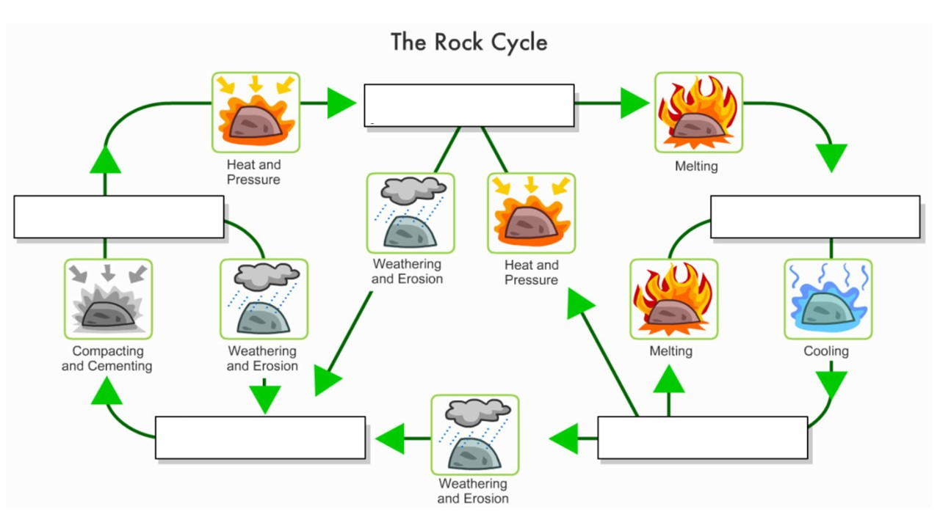

The following questions can be answered by referring back to your diagram above.

1. To go from Magma to Igneous we need to

|  |
| --- |
|  |

1. To go from Igneous back to magma we need to

|  |
| --- |
|  |

1. Making Igneous become Sediment requires

|  |
| --- |
|  |

1. To go from Sediment to Sedimentary Rock we need to

|  |
| --- |
|  |

1. To change from Sedimentary rock to Sediment we

|  |
| --- |
|  |

1. Changing from Sedimentary to Metamorphic requires

|  |
| --- |
|  |

1. Making Metamorphic become Sediment requires

|  |
| --- |
|  |

1. Changing from Metamorphic to Magma uses

|  |
| --- |
|  |

1. Changing from Igneous to Metamorphic requires

|  |
| --- |
|  |